Antowan J. Graham

October 17, 2021

CST-150 Milestone 2

Github Link: <https://github.com/AntowanG-tech/CST-150Milestone>

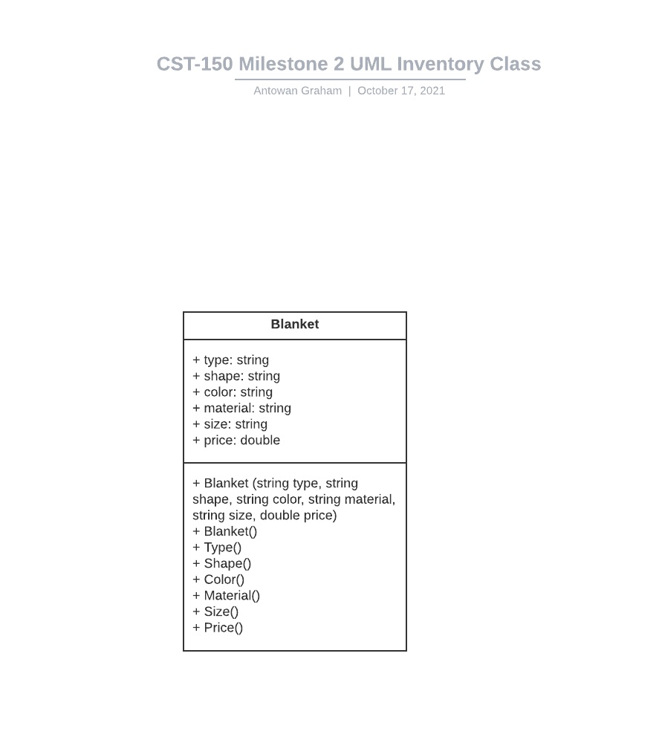

Successful Run

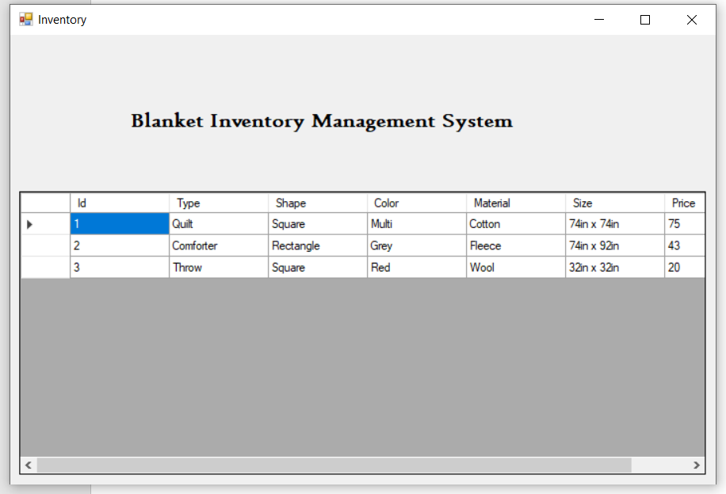

Blanket (inventory) class

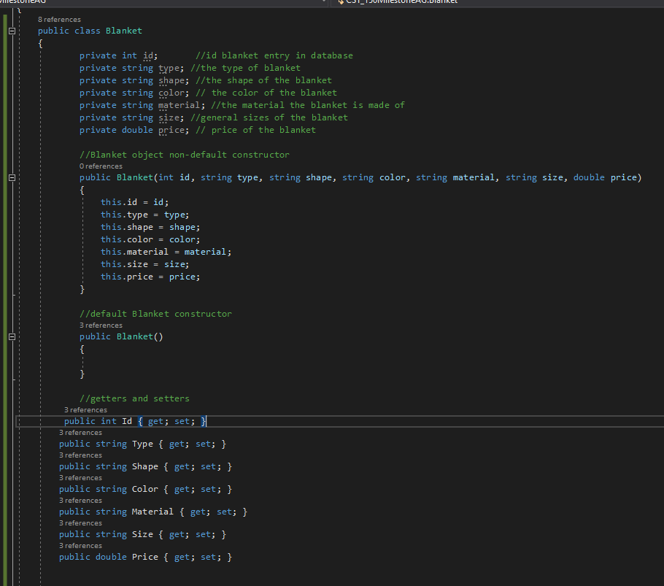

Testing the Inventory Class

